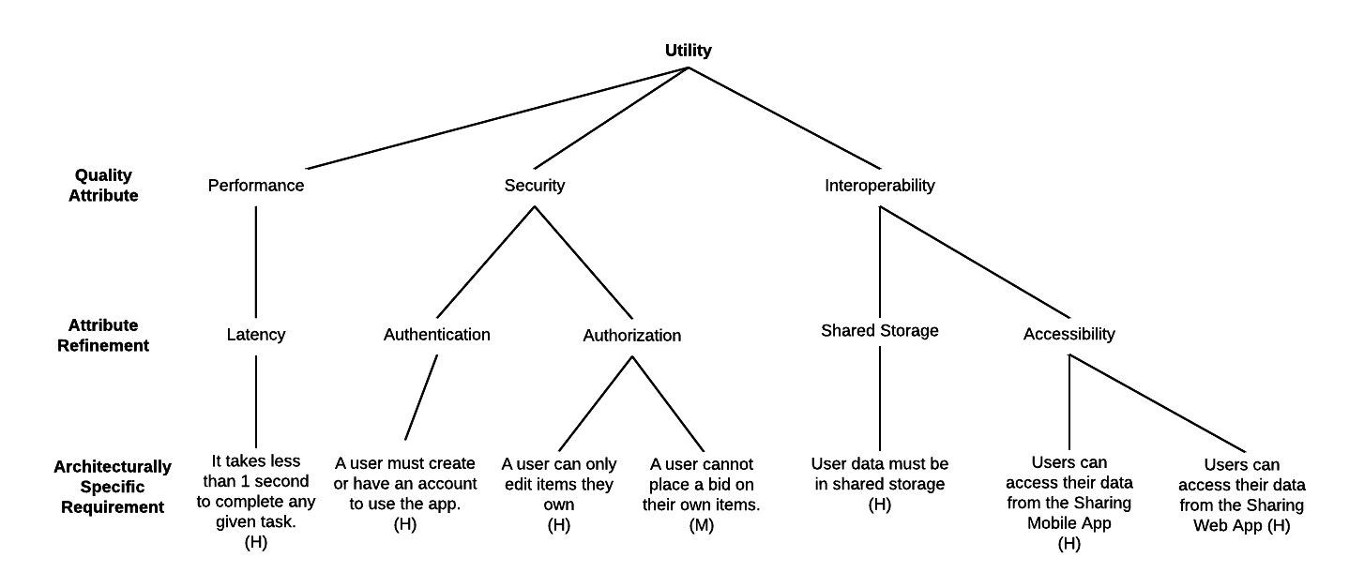



This scenario is a risk. It may not satisfy the Architecturally significant requirements (ASR). The ASR stated it need to perform within a second, but the system is not scalable and will perform more than 1 sec in many cases.



There is a risk in this scenario. Since there is no secure layer or any encryption in this app, the app are exposed to the hackers.



There is a trade of in this scenario. The user can easily log in the app and use the services without the password. However, the customer will have to account for the risk of no security.



This scenario is non-risk. As user tries to trigger an error and it is caught by the application.



This scenario is a non-risk. As user and the application perform as expected.



This scenario is a sensitivity point. The user pushes the new data while other user and system still read in the old data.



This scenario is a non-risk. The app handle the conflict as expected. All the request will be executed one by one.